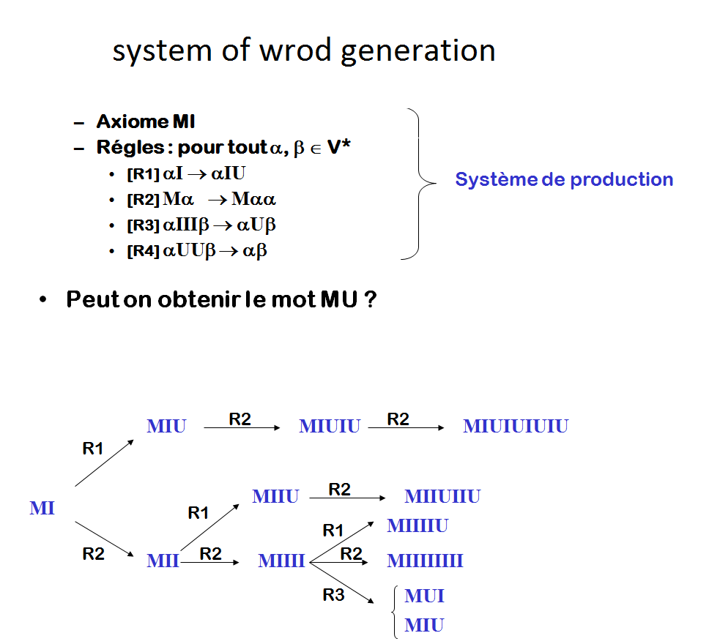
And here we see that not all problems have solutions with calculations and mathematical models
so our main goal is to create some system that answers simple queries and problems but then using deep neural learning techniques to generate some swarm intelligence using the power of the collective system that we will implement using one of different deep learning frameworks and toolkits and even libraries like caffee , torch , tensorflow or even microsoft CNTK like this example below

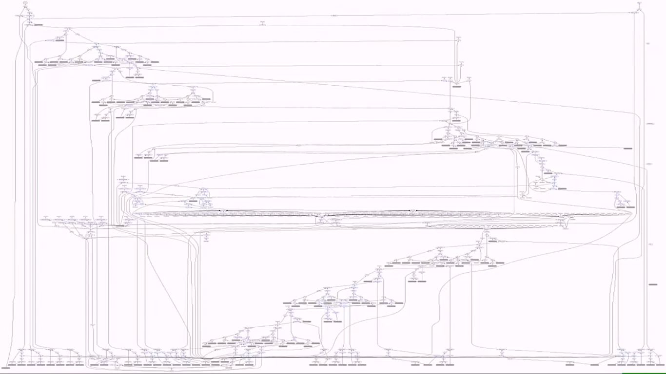
So to start understanding our system and use cases we need to classify our data like for example in watson NLC service here

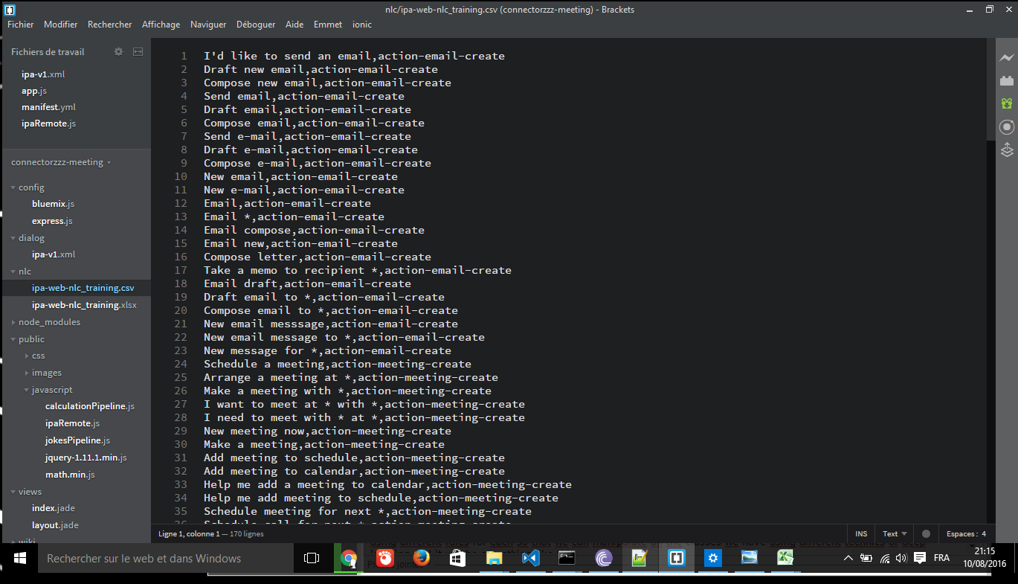
but then with big data the problem comes with which approche we zill use for defining our models
because they can be from retrieval or even generated in complex systems
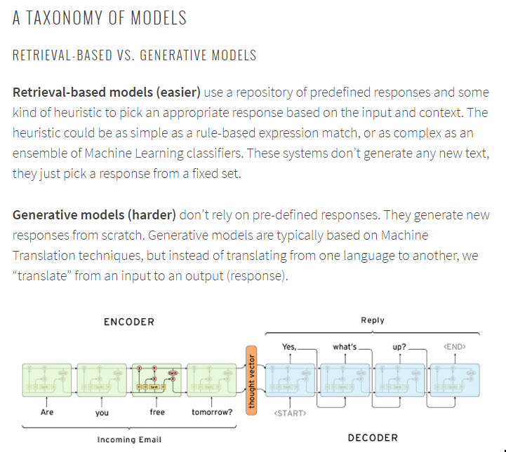

but then to try to encode queries and then decode a response will be using a third party system so we will will perform data cleaning, pre-processing, classification. While doing this one requires some NLP system to do grammatical and syntactical classifications
- Data tokenization
- Stop word removal
- Part of speech tagging
- Noun entity extraction
- Sentence parsing etc
NLP will help you here. When you do numeric classification, text classification or perform some recommendation; NLP helps to do it better

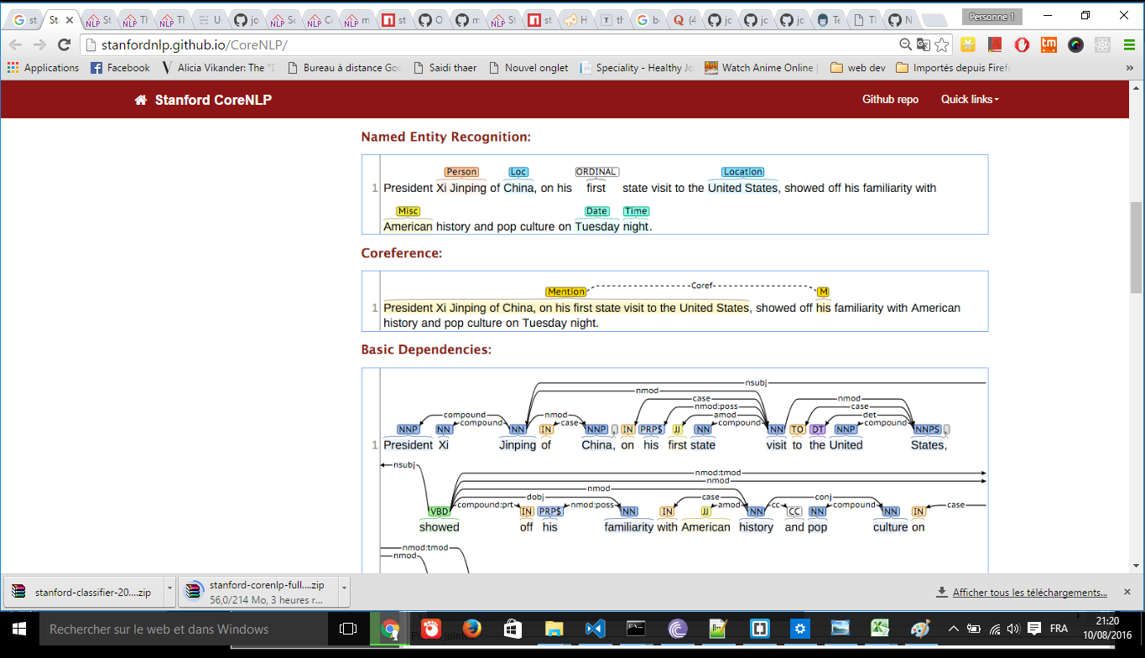

but then the need of deep learning methods and techniques is very important so that we can create our models that can one of 2

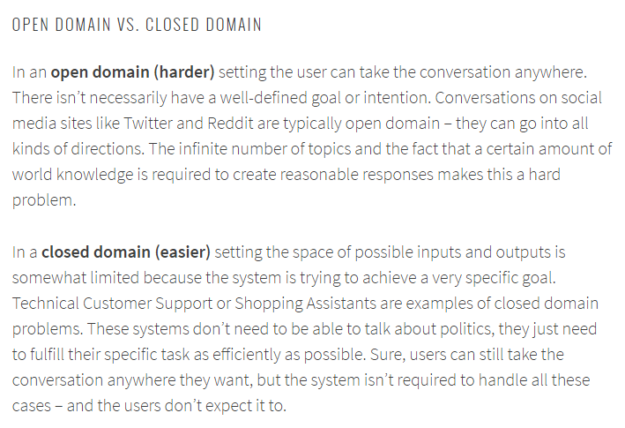

and then when we have different models for different classes we can coordinate between them using a dialog system like for this entity and intent used by api.ai services

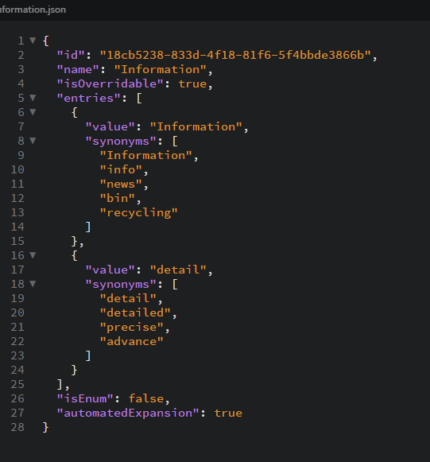
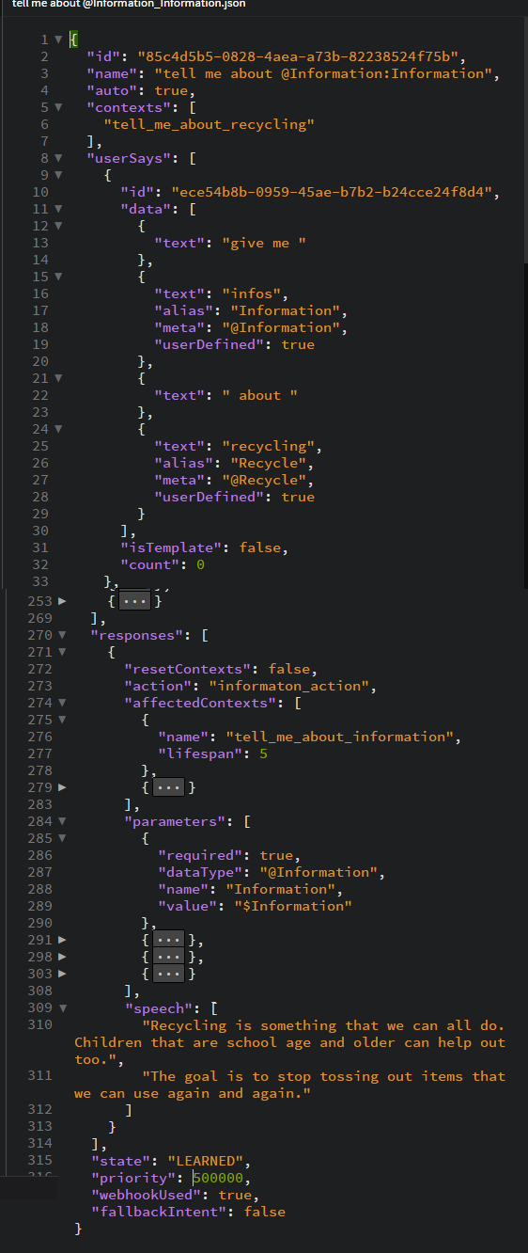

but then

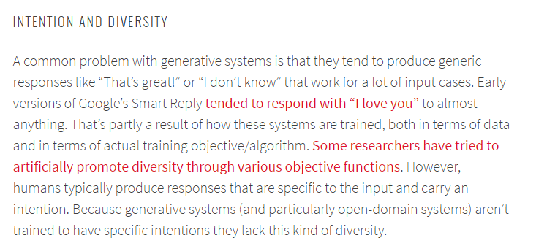
and then different studies were made for personality insights so that the AI system will formulate proper responses to all customer queries

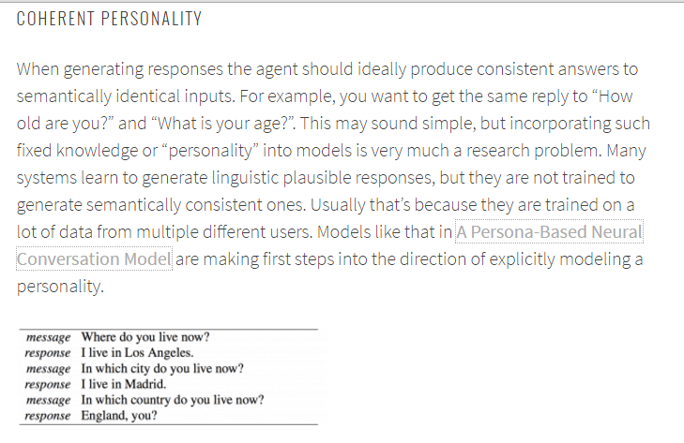

like for example the one used by watson cognitive services
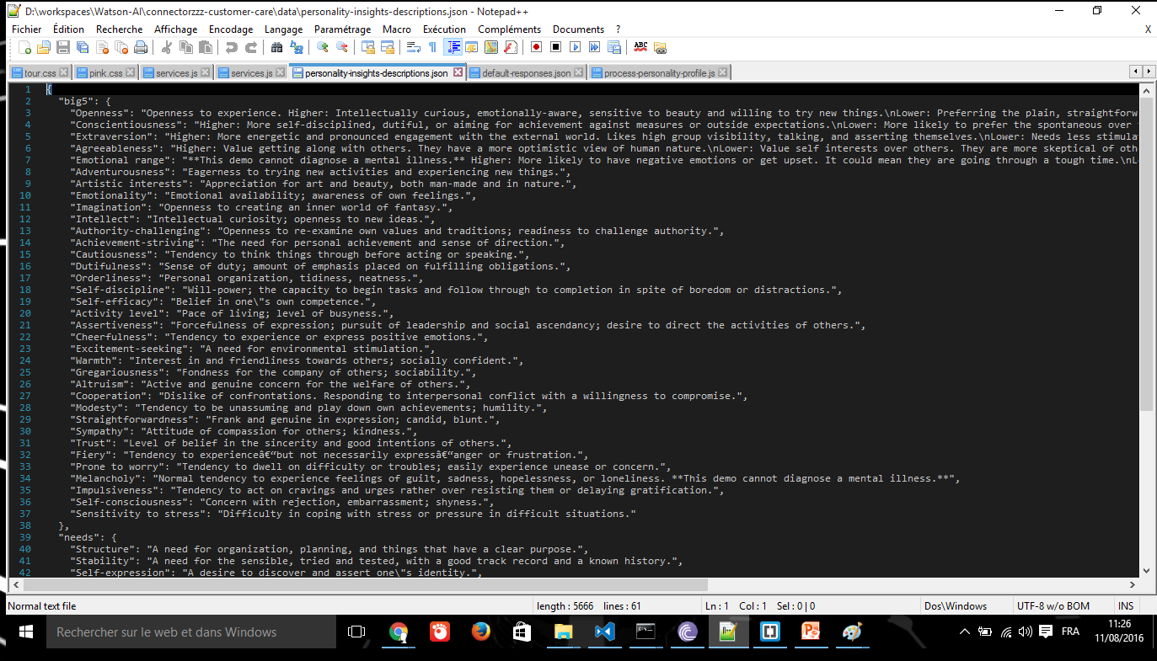

and finally make a bot system that gives a response like the one used in api.ai for example

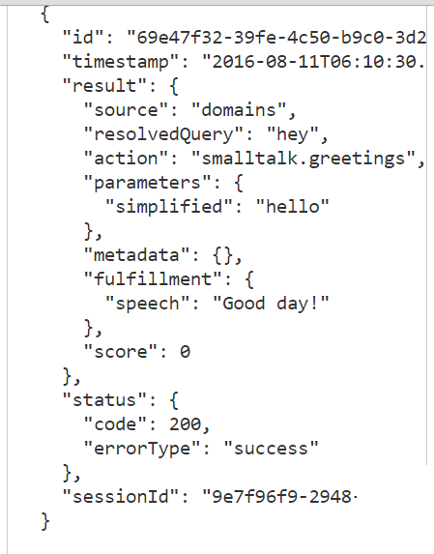
and create a BOT system that contains all those different services and coordinate with them to make one simple use case

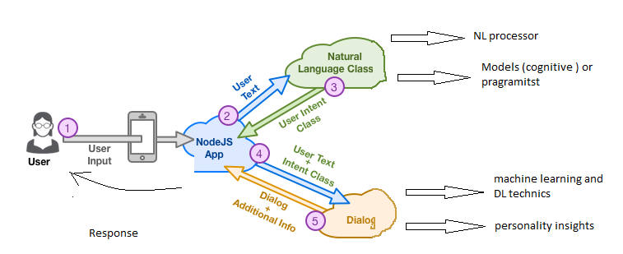

you know computers are not smart but the state of the art is to make them look like they are
but then this really can be made when meeting with big data to understand different patterns and contexts and create proper models for our different use cases

